SE 4485: Software Engineering Projects

Fall 2026

Requirement Documentation

Group Number | 9
Project Title | Skills Catalog & Inventory (Team A)
Sponsoring Company | Sabre Corporation
Sponsor(s) | Jeff Buchmiller
Students | 1. Tobenna Nwosu  2. Jason Lehman  3. Alice Askerup  4. Russel Costales  5. Kim Chau  6. Jasmine Shrestha

Skills Catalog & Inventory

- ABSTRACT
This is the Requirements Document for the Skills Catalog & Inventory project sponsored by Sabre Corporation. This project is one of the ten projects for this course SE 4485.001 at the University of Texas at Dallas. This document complies with the Software Engineering Standards set by the IEEE Standard for Software Project Management Plans (IEEE Std 1058-1998). The document sets the functional and non-functional requirements for the project.

B. TABLE OF CONTENTS

Abstract……………………………………………………………………………………….…....3
- Table of Contents…………………………………………………………………………….…….4
- List of Figures……………………………………………………………………………………...5
- List of Tables………………………………………………………………………………….……5
- Introduction……………………………………………………………………………….….…….6
1.1. Introduction to the document…………………………………………………………….……6
1.2. Purpose and Scope of the document…………………………………………………….….…6
1.3. Brief overview of the product………………………………………………………….……...6
1.4. Description of the structure of the document………………………………………….………7
- Use Case Model for Functional Requirements…………………………………………………….8
2.1. Graphic Use Case Model…………………………………………………………………...…8
2.2 Textual Description…………………………………………………………………………….9
- Rationale For Your Use Case Model……………………………………………………………...21
- Non-Functional Requirements……………………………………………………………………22
- Configuration Management………………………………………………………………………23
- Engineering Standards and Multiple Constraints…………………………………………………24
- Glossary…………………………………………………………………………………………..25
- Additional References…………………………………………………………………………….26

C. LIST OF FIGURES

- Use Case Model for Data Administration
- Use Case Model for Skill and Resource Search
- Use Case Model for Workforce Planner

D. LIST OF TABLES

- General/ Business Operations Functional Requirements
- Workforce Planner Functional Requirements
- Resource Manager Functional Requirements
- Organizational Leader Functional Requirements
- Use Case 01
- Use Case 02
- Use Case 03
- Use Case 04
- Use Case 05, 06, 07
- Use Case 08. 09
- Use Case 10
- Use Case 11
- Use Case 12
- Use Case 13
- Use Case 14
- Use Case 15
- Use Case 16
- Use Case 17
- Use Case 18
- Use Case 19
- Use Case 20
- Use Case 21
- Use Case 22

1. Introduction

1.1. Overview

The purpose of this project is to build a cloud-based software tool to help organizations overcome the challenge of tracking employee skills across complex team structures. To make workforce capabilities clear and connected, the platform links three core areas: the Skills Catalog/Master Data (standardized definitions and hierarchy of all skills), Organization Structure (company’s teams, roles, and relationships), and Skills Inventory (mapping employees to skills).

1.2. Purpose and scope of the document

The purpose of this document is to define the functional and structural requirements for developing the cloud-based software. As the semester goes on, we will explore and choose what our tech stack would be to satisfy the requirements. The scope of the document is as follows:
- Core Data Architecture: Designing the relationship between Master Data, Organization Structure, and Operational Data
- Stakeholder Groups:
  - Workforce Planners - Build & maintain the Skills catalog
  - Resource Managers - Enter, view, and update Skills per resource, creating and maintaining the Skills Inventory
  - Organizational Leaders - Skills inventory summary views to manage the existing organization and plan future workforce strategies
  - Business Operations - Load files of additional Skills into the Skills catalog and of additional skills per resource into the Skills Inventory

1.3. Brief overview of the product

A cloud-based software tool has to be designed and built to create and maintain a Skills Catalog. The tool has to be built with a focus on an exceptional user interface (UI) with the ability to enter, view, and update skills per resource, thereby creating the Skills Inventory. The purpose of this tool is to simplify the process of keeping track of which resources in the company have which skills and create a skills catalog that users can easily view, understand, and update. In the organization, leaders view summaries of skill inventory to manage organizational skills capacity and plan future workplace strategies.

1.4 Description of the structure of the document

This Project Management Plan provides a structured roadmap for the development of the Skills Catalog & Inventory system. The document is organized into the following sections:

- Introduction: Defines the project's purpose, scope, and product overview.
- Use Case Model for Functional Requirements: Describes the functional requirements using graphical models and detailed textual descriptions for each use case.
- Rationale for Your Use Case Model: Provides the justification and reasoning behind our chosen use case structure.
- Non-Functional Requirements: Specifies quality attributes, system constraints, performance requirements, and technical standards.
- Professional Standards: Sets expectations for team conduct and deliverables.
- Evidence of Configuration Management: Links to relevant repository management tools.
- Engineering Standards and Multiple Constraints: Lists the industry standards guiding the project.
- Additional References & Appendix: Includes supplementary material and the professional standards guideline.

2. Use Case Model for Functional Requirements

2.1 Graphic Use Case Model

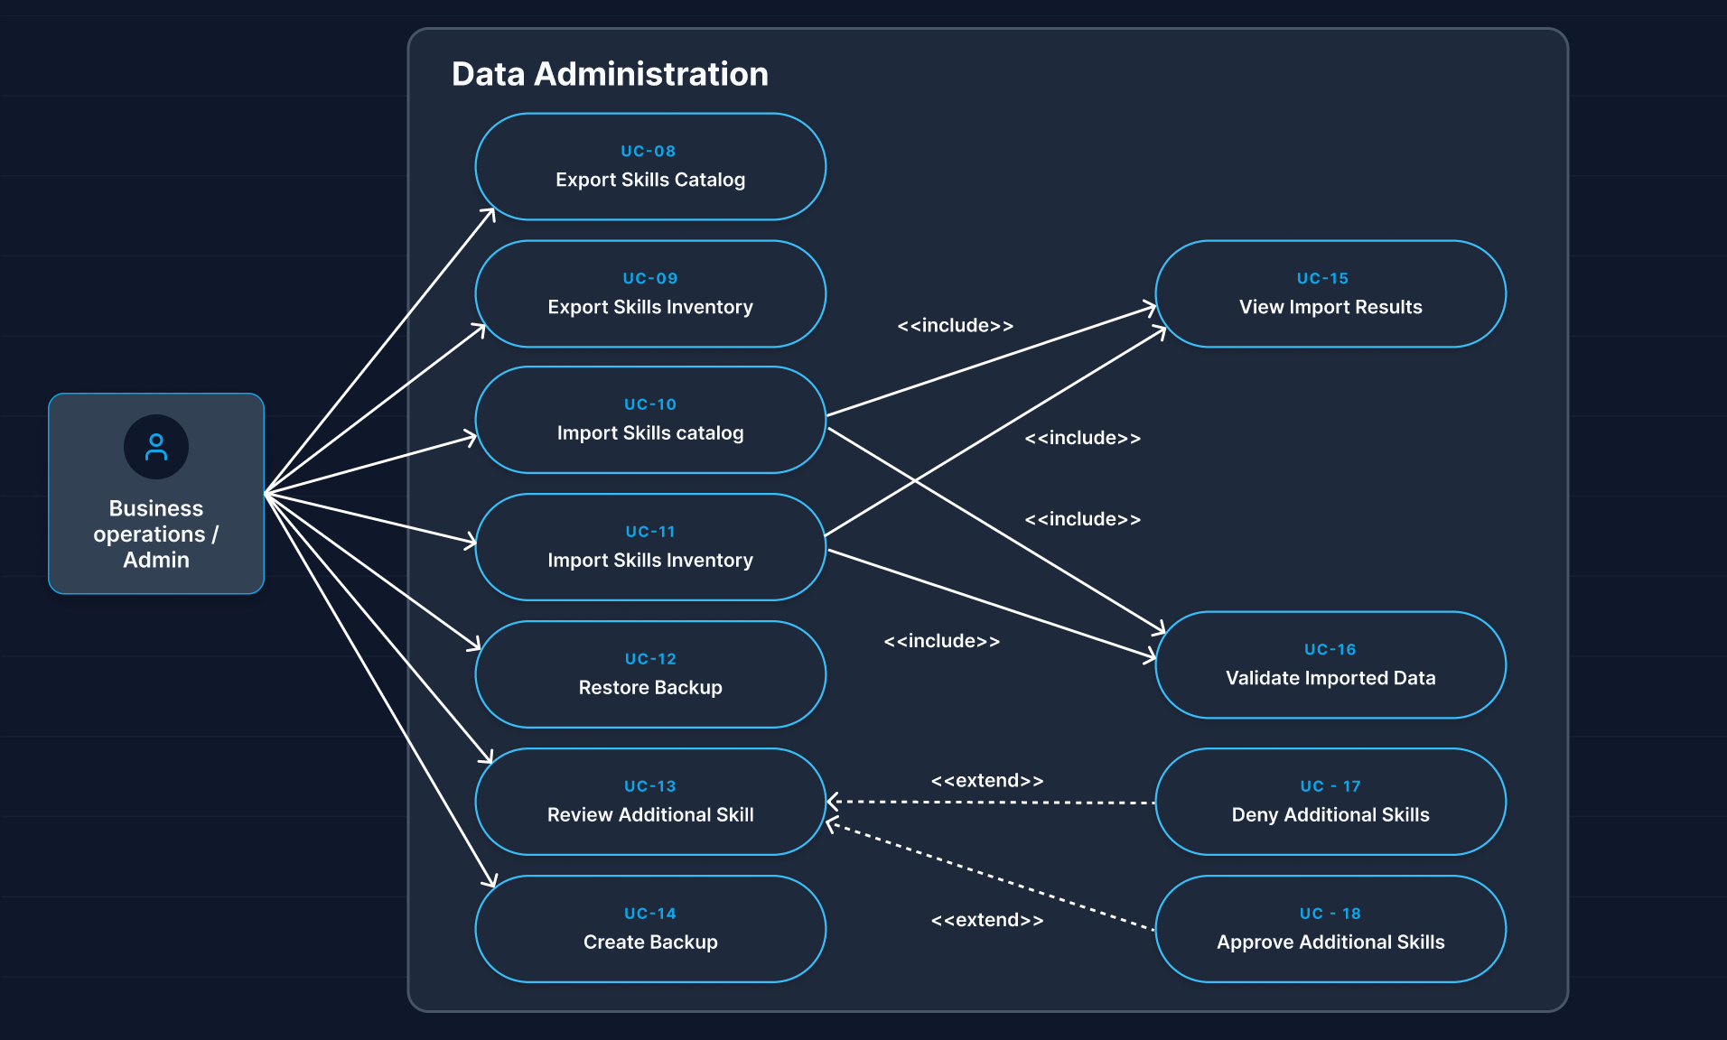
Figure 1: Use Case Model for Data Administration

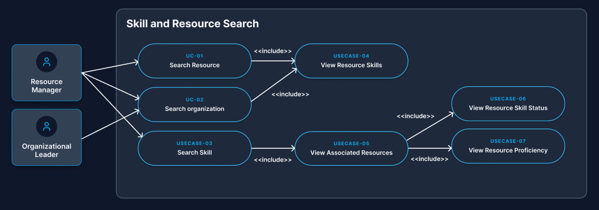
Figure 2: Use Case Model for Skill and Resource Search

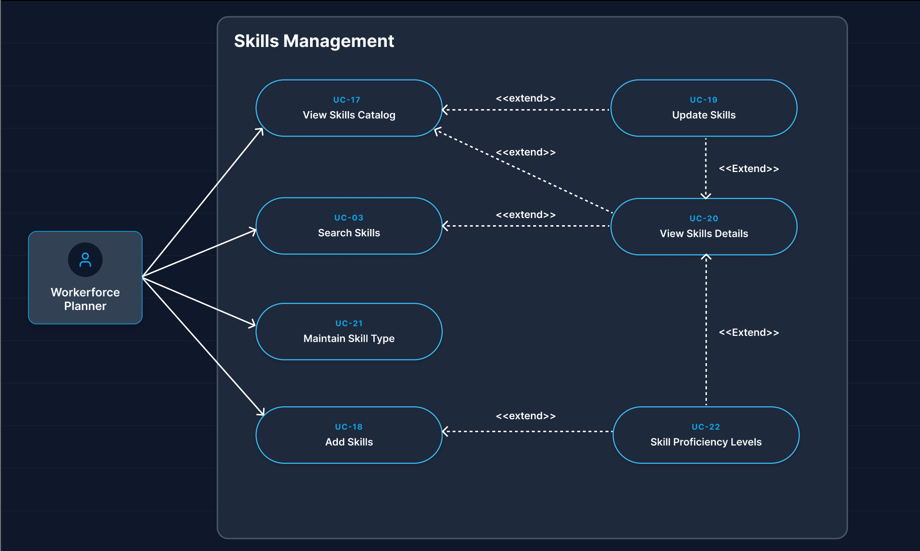
Figure 3: Use Case Model for Workforce Planner

2.2 Textual Description

General / Business Operations Functional Requirements | Description
Import Skills Catalog | The system shall allow admins to import skill catalog data from a file
Load additional skills | The system shall allow admins to load additional skills into the existing skills catalog
Validate Imported Data | The system shall validate all imported data before adding it to the database
View Import Errors/Results | The system shall allow the viewing of errors and results of imports
Export Data | The system shall allow the exportation of the skills catalog and inventory to a file
Backup | The system shall allow the creation of a backup of system data
Restoration | The system shall allow admins to restore data from a previously created backup
Approve or deny additional skills | The system shall allow admins to either approve or deny when new skill is added to the catalog
Web-based system | The system shall be web-based and accessible from the cloud
Cancel | The system shall allow the cancellation of association between resource and skill

Workforce Planner Functional Requirements | Description
Views Skills Catalog | The system shall allow Workforce Planners to view the Skills Catalog and its existing skills.
Add Skills | The system shall allow Workforce Planners to add new skills to the Skills Catalog.
Update Skills | The system shall allow Workforce Planners to update existing skill information.
Search Skills | The system shall allow Workforce Planners to search for a skill using full or partial skill names.
View Skills Details | The system shall allow Workforce Planners to select a skill to view its details such as name, type, and status of that skill.
Maintain Skill Type | The system shall support maintaining skill types.
Skill Proficiency Levels | Assign and update proficiency levels (e.g., Beginner, Intermediate, Expert) for skills assigned to resources.
Graphical UI | The system shall provide graphical UI components to help navigate and maintain complex skill data.
AI assistance | The system may provide AI-assisted functionality to maintain an efficient skills catalog.

Resource Manager Functional Requirements | Description
Creating/Maintaining Skills Inventory | The system shall allow Resource Managers to enter, view, update, and remove skills per person (resource).
Search for a specific resource or organization to view their skills | The system shall allow Resource Managers to search for a specific resource or specific organization and its resources to view their skills.
Search for a specific skill and see all associated resources | The system shall allow Resource Managers to search for a specific skill and display all resources associated with that skill along with their proficiency and status.
View UI | The system shall allow Resource Managers to access a UI focused on specific resource(s) within the organization to enter, view, and update skills per resource.
Create, view, and maintain association between skill and resource | The system shall allow Resource Managers to create, view, update, and remove associations between skills and individual resources
View specific Skill UI | The system shall allow Resource Managers to access a UI focused on skill(s) being viewed within the Skills Catalog.
Skill Validation | The system shall allow Resource Managers to validate all skill assignments and updates against predefined entries in the Master Skills Catalog.
Certification Tracking | The system shall allow Resource Managers to track certification details and verification status per resource.

Organizational Leader Functional Requirements | Description
View summary | The system shall allow OLs to view a summary of all skills
Filter Skills | The system shall allow OLs to filter the skills inventory information
View distribution | The system shall allow OLs to view a department-based distribution of skills
Graphical views | The system shall provide graphical visualization of skills inventory based on relevant filters
Skill capacity | The system shall allow OLs to identify areas of skill capacity within departments or the entire inventory
Skill Trend & Historical Analytics | The system shall allow OLs to track skill growth or decline over time across quarters or years.
Organization Hierarchy | The system shall allow OLs to view the organization hierarchy and reporting structure (who reports to whom, except for the CEO)

Use Case 01
Use Case Name | Search Resource
Participating Actors | Resource Manager
Entry Condition(s) | Resource Manager is authenticated  Organization/resource data is available
Normal Flow of Events | Resource Manager opens resource Search  Resource Manager enters search criteria  System searches available resources  System displays matching resources  Resource Manager selects a resource  System displays the resource's skills
Exit Condition(s) | Matching resource(s) and their skills displayed
Exceptions | No matching resources are found  Search criteria are invalid  Resource data is unavailable
Special Requirements | Should support searching for a specific resource.
Authorized Role(s) | Resource Manager

Use Case 02
Use Case Name | Search Organization
Participating Actors | Resource Manager  Organizational Leader
Entry Condition(s) | Resource Manager is authenticated  Organization/resource data is available
Normal Flow of Events | Resource Manager opens organization search  Resource Manager enters search criteria  System searches organizational structures  System displays matching organizations  Resource Manager selects an organization  System displays resources in the organization  System displays skills of selected resources
Exit Condition(s) | Organization and associated resources are displayed
Exceptions | Organization cannot be found  Organization has no resources
Special Requirements | Ensure organization relationships are represented clearly
Authorized Role(s) | Resource Manager  Organizational Leader

Use Case 03
Use Case Name | Search Skills
Participating Actors | Workforce Planner  Resource Manager
Entry Condition(s) | User is authenticated  Skills catalog is available
Normal Flow of Events | User opens the skills search interface  User enters full or partial skill name  System searches skills catalog  System identifies matching skills  System displays the matching results  User selects a result if additional information is required
Exit Condition(s) | Matching skills are displayed
Exceptions | Search returns no results  Search term is empty
Special Requirements | Support full and partial names  Presented through graphical UI
Authorized Role(s) | Resource Manager  Workforce Planner  Administrator

Use Case 04
Use Case Name | View Resource Skills
Participating Actors | Organizational Leader  Resource Manager
Entry Condition(s) | User is authenticated  Skills catalog is available
Normal Flow of Events | User selects a resource  System retrieves the resource's skill associations and each skill's proficiency  System displays the resource's skills  User reviews information
Exit Condition(s) | Skills associated with selected resource are displayed
Exceptions | Resource cannot be found  Resource has no associated skills  Inventory cannot be retrieved
Special Requirements | UI should focus on selected resource(s)  Skill information should be repeated
Authorized Role(s) | Resource Manager, Organizational leader

Use Case 05, 06, 07
Use Case Name | View associated resources, proficiencies, and statuses
Participating Actors | Organizational leader  Resource Manager
Entry Condition(s) | Skill is selected  Skill inventory is available
Normal Flow of Events | User opens skill interface  System searches for all resources with the selected skill  System displays resource and associated level of proficiency and status
Exit Condition(s) | Associated resources, proficiency, and status are displayed
Exceptions | No resources associated with the skill  Inventory data cannot be retrieved
Special Requirements | Results must include associated resource, proficiency, and status
Authorized Role(s) | Resource Manager  Organizational Leader

Use Case 08,09
Use Case Name | Export Skills Catalog and Skills Inventory
Participating Actors | Business operations
Entry Condition(s) | User is authenticated  Exportable skills catalog and inventory data exist
Normal Flow of Events | User selects export  User selects the data to export  System retrieves the requested data  System generates an export file  System provides the file to the user
Exit Condition(s) | Requested data has been exported
Exceptions | No data exists  Export fails  User cancels export
Special Requirements | System must support export of entire Skills catalog and Skills inventory data
Authorized Role(s) | Business Operations / Administrator

Use Case 10
Use Case Name | Import Skills Catalog
Participating Actors | Business operations
Entry Condition(s) | User is authenticated  Import file is available
Normal Flow of Events | User selects skills catalog import  User uploads the file  System reads the file  System validates the imported data  System identifies valid and invalid records  System adds valid records to the skills catalog  System generates an import result  System displays the result
Exit Condition(s) | Valid catalog data has been added to the skills catalog data
Exceptions | File format is invalid  File cannot be read  Validation fails  Duplicate data is detected
Special Requirements | All imported data must be validated before being added to the database
Authorized Role(s) | Business Operations / Administrator

Use Case 11
Use Case Name | Import Skills Inventory
Participating Actors | Business operations
Entry Condition(s) | Import file is available  Resources and skills referenced by the file can be identified
Normal Flow of Events | User selects skills inventory import  User uploads the file  System reads the file  System validates the imported data  System checks referenced resources and skills  System adds valid inventory associations  System displays import results
Exit Condition(s) | Valid inventory information has been added
Exceptions | File format is invalid  Resource or skill cannot be found  Validation fails  Duplicate association exists
Special Requirements | Imported skill assignments should correspond to the master skills catalog
Authorized Role(s) | Business operations / Administrator

Use Case 12
Use Case Name | Restore Backup
Participating Actors | Business operations
Entry Condition(s) | User is authenticated  At least one valid backup exists
Normal Flow of Events | Administrator selects restore  System displays available backups  Administrator selects a backup  System requests confirmation  System restores the selected data  System confirms completion
Exit Condition(s) | System data has been restored from the selected backup
Exceptions | Backup is unavailable  Backup is corrupted  Restoration fails
Special Requirements
Authorized Role(s) | Business Operations / Administrator

Use Case 13
Use Case Name | Review Additional Skill
Participating Actors | Business operations
Entry Condition(s) | A new skill has been submitted for approval
Normal Flow of Events | Administrator opens pending skill submissions  System displays submitted skill information  Administrator reviews the proposed skill  Administrator chooses to approve or deny the skill
Exit Condition(s) | Skill has been approved or denied
Exception(s) | No pending skills exist  Skill information is incomplete  Submission cannot be retrieved
Special Requirements | Approval status must be recorded
Authorized Role(s) | Business Operations / Administrator

Use Case 14
Use Case Name | Create Backup
Participating Actors | Business operation
Entry Conditions (s) | The user is authenticated. System data is available for backup.
Normal Flow of Events | Business Operations selects the backup option  System prepares the Skills Catalog and Skills Inventory, and related data for backup  System creates the backup  System stores the backup  System announces that the backup was successfully created.
Exit Conditions(s) | A backup of the system data has been created and stored.
Exception(s) | Backup creation fails  Data can not be accessed  Storage is full
Special Requirements | The backup must preserve the data required to restore the Skills Catalog and Skills Inventory.
Authorized Role(s) | Business Operations

Use Case 15
Use Case Name | View Import Results
Participating Actors | Business Operations / Administrator
Entry Condition(s) | Skills Catalog and Skills Inventory are imported
Normal Flow of Events | System completes validation of the imported file  System compiles results summary showing valid and invalid records  System displays results to user  User reviews which records were successfully added or rejected
Exit Condition(s) | Import results have been displayed to user
Exceptions | No results available to display  Results fail to load or display correctly
Special Requirements | Clearly separate successful imports from failed/rejected records in display
Authorized Role(s) | Business Operations / Administrator

Use Case 16
Use Case Name | Validate Imported Data
Participating Actors | Business Operations / Administrator
Entry Condition(s) | The user is authenticated. A file has been uploaded for import into either the Skills Catalog or Skills Inventory.
Normal Flow of Events | System reads uploaded file  System checks record against existing data  System identifies valid records  System identifies invalid or conflicting records  System prepares report for user
Exit Condition(s) | Imported data is validated and separated into valid and invalid records
Exceptions | File format is unreadable, or corrupted  No records are in the file  Record references skill not in Catalog  Record is missing required fields
Special Requirements | Clearly distinguishes valid records from invalid ones before committing data
Authorized Role(s) | Business Operations / Administrator

Use Case 17
Use Case Name | View Skills Catalog
Participating Actors | Workforce Planner
Entry Condition(s) | Workforce Planner is authenticated, and Skills Catalog is available.
Normal Flow of Events | Workforce Planner opens the Skills Catalog.  System retrieves the existing skills from the Skills Catalog.  System displays existing skills.  Workforce Planner reviews the Skills Catalog.  Workforce Planner may select a skill.
Exit Condition(s) | The Skills Catalog and its existing skills are displayed.
Exceptions | The Skills Catalog and the existing skills are displayed.
Special Requirements | The Skills Catalog should be displayed with a clear graphical UI.
Authorized Role(s) | Workforce Planner

Use Case 18
Use Case Name | Add Skills
Participating Actors | Workforce Planner
Entry Condition(s) | Workforce Planner is authenticated
Normal Flow of Events | Workforce Planner selects the option to add a new skill  Workforce Planner enters the skill details (name, category, description, and type)  System validates the entered skill details and checks for duplicate entries  System saves the new skill to the Skills Catalog  System displays a success confirmation message
Exit Condition(s) | New skill is successfully added to the Skills Catalog
Exceptions | Skill already exists in the Skills Catalog  Required skill information is missing or invalid  Workforce Planner cancels the operation
Special Requirements | System must prevent duplicate skill entries in the catalog  Changes must be approved by administration
Authorized Role(s) | Workforce Planner

Use Case 19
Use Case Name | Update Skills
Participating Actors | Workforce Planner
Entry Condition(s) | Workforce Planner is authenticated and skills catalog is available
Normal Flow of Events | Workforce Planner opens and views skills catalog  System displays existing skills  Workforce Planner reviews existing skills  Workforce Planner extends skills catalog to update skills  Workforce Planner edits skill details to maintain catalog  System validates changes  System saves the changes to skills catalog  System displays success confirmation message
Exit Condition(s) | Changes to skill details are saved
Exceptions | Workforce Planner cancels the changes  The skill does not exist in the skills catalog
Special Requirements | Changes must be approved by administration
Authorized Role(s) | Workforce Planner

Use Case 20
Use Case Name | View Skills Catalog
Participating Actors | Workforce Planner
Entry Condition(s) | Workforce Planner is authenticated
Normal Flow of Events | Workforce Planner opens the Skills Catalog  Workforce Planner retrieves skills from the Skills Catalog  System display skills from Skills Catalog  Workforce Planner reviews the Skills Catalog
Exit Condition(s) | Existing skills from the Skills Catalog are displayed
Exceptions | Skills Catalog is empty  Skills Catalog data cannot be retrieved
Special Requirements | Must present skills using a graphical UI
Authorized Role(s) | Workforce Planner

Use Case 21
Use Case Name | View Skills Details
Participating Actors | Workforce Planner
Entry Condition(s) | Workforce Planner is authenticated and Skills Catalog is available.
Normal Flow of Events | Workforce Planner opens the Skills Catalog  Workforce Planner selects a specific skill  System retrieves skill details (such as name, type, status, and description)  System displays the skill's details  Workforce Planner reviews the skill details
Exit Condition(s) | Detailed information for the selected skill is displayed.
Exceptions | Skill cannot be found  Skill details data cannot be retrieved
Special Requirements | Must present skill details using a graphical UI.
Authorized Role(s) | Workforce Planner

Use Case 22
Use Case Name | View Skill Proficiency Levels
Participating Actors | Workforce Planner
Entry Condition(s) | Workforce Planner is authenticated and Skills Catalog is available
Normal Flow of Events | Workforce Planner opens the Skills Catalog  Workforce Planner selects a specific skill  Workforce Planner requests to view proficiency levels for the skill  System retrieves defined proficiency levels (e.g., Beginner, Intermediate, Expert)  System displays the skill proficiency levels
Exit Condition(s) | Proficiency levels associated with the selected skill are displayed
Exceptions | Skill cannot be found  Proficiency levels for the skill are not defined
Special Requirements | Must present proficiency levels using a graphical UI
Authorized Role(s) | Workforce Planner

3. Rationale For Use Case Models

The use case model is organized around the stakeholder groups — Workforce Planners, Resource Managers, Organizational Leaders, and Business Operations. Each group interacts with the Skills Catalog and Skills Inventory for different purposes.

Workforce Planners build and maintain the Skills Catalog. This includes viewing the catalog, adding skills, updating skills, and searching for skills details. The relationships are extend as viewing details, updating skills, and setting proficiency levels are optional and not steps that occur every time. UC-19 (Update Skills) extends UC-17 (View Skills Catalog) as a planner can optionally update a skill when viewing a catalog. UC-20 (View Skills Details) extends UC-03 (Search Skills) since full details only display if the Planner chooses to. UC-19 (Update Skills) extends UC-20 (View Skills Details) since a Planner can choose to update skills after viewing details. UC-22 (Skill Proficiency Levels) extends UC-20 (View Skills Details) and UC-18 (Add Skills) since setting proficiency levels is an optional step. UC-21 (Maintain Skill Type) is standalone as it is not a step of search, add, or update.

Resource Managers connect resources to skills by assigning, updating, and removing skills. Organizational Leaders review summaries, filters, and trends related to workforce planning. Since the Resource Managers and Organizational Leaders need to search for and view resource and skill data, an include was used to group shared search and view behavior — UC-01 (Search Resource) and UC-02 (Search Organization) includes UC-04 (View Resource Skills), and UC-03 (Search Skills) includes UC-05 (View Associated Resources) — rather than repeating across use cases. UC-05 (View Associated Resources) also include UC-06 (View Resource Skill Status) and UC-07 (View Resource Proficiency) since status and proficiency are typically together in the resource-skill relationship.

Business Operations handle administrator tasks, such as importing and exporting of files. They are grouped under a Data Administration model. UC-10 (Import Skills Catalog) and UC-11 (Import Skills Inventory) includes UC-15 (View Import Results) and UC-16 (Validate Imported Data) as an import needs to be validated and its results shown. UC-13 (Review Additional Skill) has an extend relationship to UC-17 (Deny Additional Skills) and UC-18 (Approve Additional Skills) since reviewing a skill is conditionally denied or approved. Exports (UC-08, UC-09) and Backups (UC-12, UC-14) are standalone since it does not use any validation steps.

4. Non-Functional Requirements

NFR | Description
Reliability of the system | The system must be able to recover from hardware or software issues in five minutes
Speed of the system | The system must respond to user input in less than 500 milliseconds under normal load.
Maintainability of the system | All updates and feature patches must deploy seamlessly into the program with zero downtime for the users.
Scalability of the system | The system must be able to support at least 100,000 users simultaneously without degradation of speed or usability of the system.
Security of the system | The system must protect organizational and resource data by restricting system functionality based on authorized user roles.
Usability of the system | The system must provide an user friendly interface that allows the user to navigate, search, view, and maintain the skills catalog easily
Availability of the system | The system must maintain an uptime of at least 99% during normal business hours, except during scheduled maintenance periods.
Accessibility of the system | The UI must comply with standard ADA regulations to ensure that the UI accounts with individuals with disabilities.
Environment Requirements | The system shall operate as a web-based system in a cloud environment.

5. Configuration Management

- Github Repository: https://github.com/kimchau123/SE-4385-Group-9

Name | Version Before | Version After | Difference between 2 consecutive versions | Review | Comments
Tobenna | 0.00 | 0.01 | Document Created | Shipped | Start of our project
Tobenna | 0.01 | 0.02 | Template Added to Document | Shipped
Russel | 0.02 | 0.03 | Abstract | Shipped
Tobenna | 0.03 | 0.04 | Introduction | Shipped
Team | 0.04 | 0.05 | Configuration Management | Shipped
Team | 0.06 | 0.07 | Define Functional Requirements | Shipped
Team | 0.07 | 0.08 | Graphical Use Case Model for FRs | Shipped
Team | 0.08 | 0.09 | Textual Description for each Use Case | Shipped | FRs complete
Team | 0.09 | 0.10 | Non-functional Requirements | Shipped
Team | 0.10 | 0.11 | Professional Standards | Shipped
Team | 0.11 | 0.12 | ENGINEERING STANDARDS AND MULTIPLE CONSTRAINTS | Shipped
Team | 0.12 | 0.13 | ADDITIONAL REFERENCES | Shipped
Team | 0.13 | 0.14 | Formatting the Document | Shipped

6. Engineering Standards and Multiple Constraints

- IEEE Std 830-1998: Software Requirements [pdf]
- IEEE Std 29148: Requirements Engineering [pdf]
- ISO/IEC/IEEE Std 29148-2018: Systems and Software Engineering
  - Life Cycle Processes
  - Requirements Engineering [pdf]

Students should work with their project sponsor(s) to identify all the standards and constraints that should be applied for preparing this document. Additional materials that are not listed above can be included.

7. Glossary
- Resources: Individual employees or personnel within the organization
- Skills Catalog (Master Data): A centralized, standardized repository defining all skills, categories, types, and proficiency hierarchies across the organization.
- Skills Inventory: The database mapping individual resources to their specific skills, proficiency levels, and verification status.
- Organization Structure / Hierarchy: The structural representation of company teams, roles, departments, and reporting relationships ("who reports to whom").
- Workforce Planners: Stakeholders responsible for creating, building, and maintaining the Skills Catalog and skill definitions.
- Resource Managers: Stakeholders responsible for managing resource-skill associations, updating individual skills inventory, and tracking certifications.
- Organizational Leaders: Executive and managerial stakeholders who view summary analytics, skill capacity distributions, and workforce trends.
- Business Operations / Admin: System administrators responsible for data imports/exports, backup and restoration, data validation, and reviewing new skill requests.
- Skill Proficiency Levels: Standardized capability tiers (e.g., Beginner, Intermediate, Expert) assigned to resources for specific skills.

8. Additional References

  - Lamsweerde, A.V., 2009. Requirements Engineering: From System Goals to UML Models to Software Specifications. John Wiley

Each group may include other related references that are not listed above.

